Instagram Performance Analytics Report
Brand: Sugar Cosmetics
Project Summary
This project focuses on analyzing the Instagram performance of Sugar Cosmetics using historical post-level data. The dataset contains information related to post dates, content types, reach, impressions, and various engagement metrics such as likes, comments, shares, and saves.
The analysis was performed using a structured data pipeline built with dbt for data transformation and modeling, PostgreSQL as the data warehouse, and Power BI for visualization and dashboard reporting. The project follows a layered data modeling approach consisting of raw data ingestion, staging transformations, intermediate analytical models, and final fact tables optimized for reporting.
Key performance indicators (KPIs) such as total posts, total likes, total comments, total reach, and average engagement rate were calculated to evaluate overall account performance. Additional analyses were conducted to study posting frequency trends, identify top-performing posts, compare post formats, analyze engagement patterns by weekday, evaluate hashtag performance, and visualize engagement funnels.
The final output of the project is an interactive Power BI dashboard that presents actionable insights for marketing and business stakeholders. These insights can be used to refine posting strategies, optimize content formats, and improve overall audience engagement on Instagram.

Problem Statement
Sugar Cosmetics is an actively growing beauty brand that uses Instagram as a major marketing channel to promote products, engage with customers, and build brand awareness. However, without structured data analysis, it becomes difficult to understand which types of content perform best, when audiences are most active, and how engagement varies across different campaigns and posting strategies.
The marketing team needs clear, data-driven insights to evaluate past Instagram performance and optimize future content strategies. This includes understanding overall engagement, reach, post-performance by format, audience interaction patterns, hashtag effectiveness, and growth trends over time.
Therefore, the objective of this project is to analyze historical Instagram performance data and convert it into meaningful insights that can help improve content planning, engagement strategies, and return on investment (ROI) from organic social media marketing.

1. Introduction

1.1 Objective
The objective of this project is to analyze the Instagram performance of Sugar Cosmetics using given historical post-level dataset. The analysis focuses on understanding engagement behavior, content effectiveness, posting trends, and audience interaction patterns in order to support data-driven social media strategy decisions.
The study aims to evaluate both overall account performance as well as identify specific content and timing strategies that contribute to higher engagement and reach.

1.2 Dataset Overview
The dataset contains post-level Instagram performance data with the following key attributes:
- Post date
- Post type (Image, Video, Carousel)
- Campaign type
- Hashtags
- Engagement metrics: Likes, Comments, Shares, Saves
- Reach and Impressions
- Profile visits and follows
Each row represents a single Instagram post and its associated performance metrics.

2. Methodology

2.1 Data Preparation
The data was first cleaned and standardized to ensure consistency and reliability of analysis. This included:
- Converting post dates to standard date formats.
- Normalizing text fields such as hashtags and post types.
- Ensuring numeric engagement metrics were properly cast for calculations.
- Removing formatting inconsistencies in hashtag values.
- Derived metrics such as engagement rate were calculated using the formula:
Engagement Rate = (Likes + Comments + Shares + Saves) / Reach.

2.2 Tools Used
PostgreSQL – Data storage and querying
dbt (Data Build Tool) – Data transformation, metric calculation, and modeling
Power BI – Visualization, dashboarding, and business reporting
All metrics were calculated at the data modeling stage and visualized using Power BI dashboards.

3. Analysis & Insights

3.1 Overview KPIs – Brand Summary
- Key performance indicators were calculated to assess overall account performance:
Total number of posts
Total likes received
Total comments received
Total reach
Average engagement rate
- Insight:
The overall engagement rate indicates how effectively content converts reach into meaningful interaction. A moderate engagement rate suggests steady audience interaction, but also leaves room for content optimization.

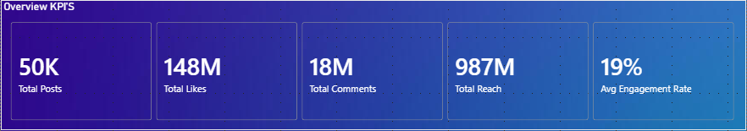

3.2 Posting Frequency Over Time
- Monthly post counts were analyzed to understand content publishing consistency.
- Insight:
Posting activity fluctuates across months, indicating periods of higher and lower marketing activity. Inconsistent posting can affect audience retention and algorithm visibility.
Maintaining a consistent posting schedule may help improve long-term engagement.

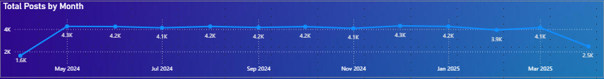

3.3 Top 10 Posts by Likes
- Posts were ranked based on total likes to identify high-performing content.
- Insight:
Top-performing posts often align with specific campaigns or emotionally appealing content. These posts can serve as templates for future creative strategies.
High likes suggest strong immediate audience resonance.

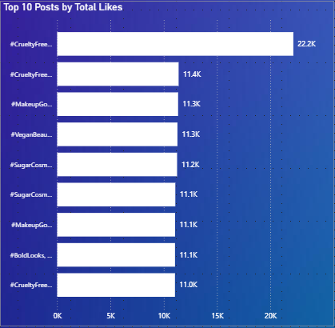

3.4 Top Posts by Engagement Rate
- Posts were ranked based on engagement rate to identify quality-driven content performance.
- Insight:
Some posts with moderate reach achieved higher engagement rates, indicating strong content relevance even with smaller exposure.
This suggests that optimizing content quality can be as important as increasing reach.

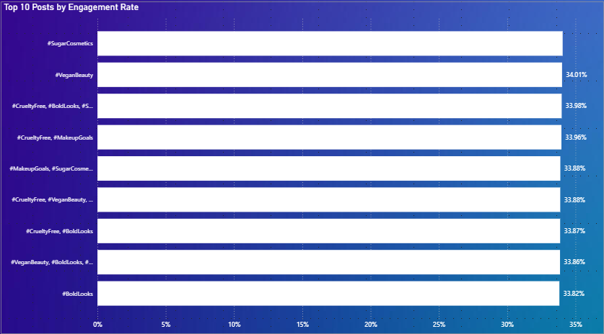

3.5 Post Type Performance Comparison
- Average likes, comments, and saves were compared across post formats.
- Insight:
Different post formats show varying performance patterns. For example:
Videos may drive higher engagement
Carousels may encourage saves
Images may generate quicker likes
Understanding these differences helps tailor content format based on campaign goals.

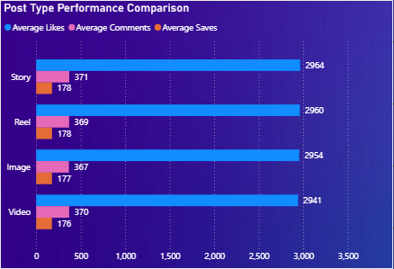

3.6 Day of Week Performance Analysis
- Engagement levels were analyzed across weekdays.
- Insight:
Certain days show consistently higher engagement, suggesting optimal posting windows.
Posting during high-performing days can improve visibility and interaction without increasing content volume.

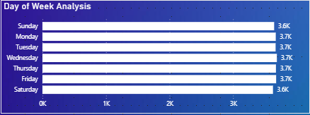

3.7 Engagement Funnel Analysis
- A funnel visualization was created using:
Impressions → Reach → Likes → Comments → Shares → Saves
- Insight:

There is a natural drop-off at each interaction stage, which is expected. However, sharper drops between certain stages may indicate areas where content could better encourage deeper interaction, such as sharing or saving.
This helps identify where engagement optimization efforts should focus.

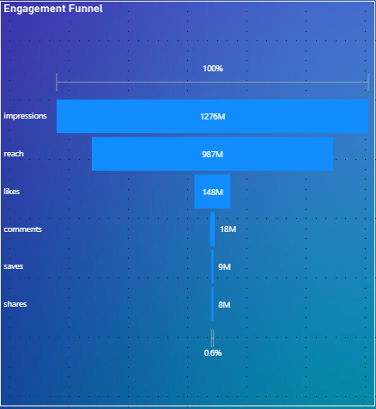

3.8 Hashtag Performance Analysis
- Hashtags were analyzed based on:
Frequency of use
Average engagement rate
Average reach
- Insight:
Some hashtags are frequently used but do not necessarily drive higher engagement, while others show strong engagement performance even with lower usage.
Strategic hashtag selection should balance popularity and performance.

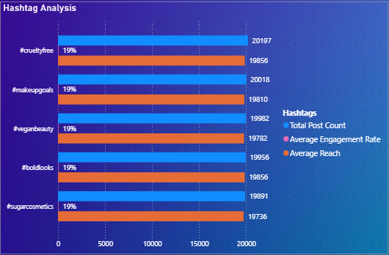

4. Business Recommendations
Based on the analysis, the following strategies are recommended:
Increase consistency in posting frequency to maintain algorithm visibility and audience engagement.
Prioritize content formats with higher engagement rates, such as videos or carousel posts, especially during campaigns.
Schedule posts on high-performing weekdays to maximize organic reach.
Reuse creative elements from top-performing posts, such as themes, visuals, or messaging style.
Adopt high-performing hashtags strategically instead of relying solely on popular tags.
Optimize funnel drop-off points by designing content that encourages saves and shares, such as tutorials or product usage tips.

5. Conclusion
This analysis provided a comprehensive overview of Sugar Cosmetics’ Instagram performance using engagement, reach, and content-level metrics.
By combining performance trends with content behavior analysis, the study highlights opportunities to improve posting strategies, content formats, and audience targeting.
The insights generated can support more data-driven marketing decisions and help maximize return on organic social media efforts.

Prepared by: A. Mayur Reddy
Role: Business Analytics Intern Applicant
Date: 24th January, 2026

